**DOMAIN WINTER WINNING CAMP ASSIGNMENT**

**Student Name: Aditya Dhankhar UID: 22BCS10642**

**Branch: BE-CSE::CS201 Section/Group: 22BCS_FL_IOT-603/A**

**Semester: 5th**

➢ **DAY-6 [25-12-2024]**

**1. Binary Tree Inorder Traversal *(Very Easy)***

Given the root of a binary tree, return the inorder traversal of its nodes' values.

**Example 1:**

Input: root = [1,null,2,3]

Output: [1,3,2] **Explanation:**

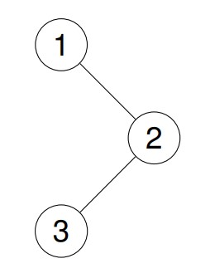

**Example 2:**

Input: root = [1,2,3,4,5,null,8,null,null,6,7,9]

Output: [4,2,6,5,7,1,3,9,8] **Explanation:**

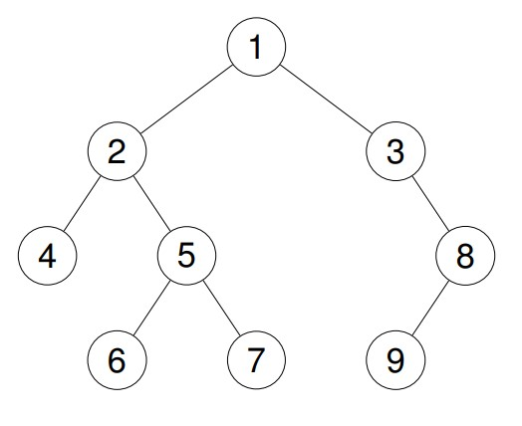

**Constraints:**

The number of nodes in the tree is in the range [0, 100].

-100 <= Node.val <= 100

**Implementation/Code:**

#include <iostream> #include <vector>

using namespace std;

// Definition for a binary tree node.

struct TreeNode {

int val;

TreeNode* left;

TreeNode* right;

TreeNode() : val(0), left(nullptr), right(nullptr) {}

TreeNode(int x) : val(x), left(nullptr), right(nullptr) {}

TreeNode(int x, TreeNode* left, TreeNode* right) : val(x), left(left), right(right) {} };

class Solution { public:

vector<int> inorderTraversal(TreeNode* root) {

vector<int> result; inorder(root, result); return result;

}

private:

void inorder(TreeNode* node, vector<int>& result) { if (!node) return; inorder(node->left, result); result.push_back(node->val);

inorder(node->right, result);

}

};

// Helper function to create a binary tree

TreeNode* createTree() { TreeNode* root = new TreeNode(1); root->right = new TreeNode(2); root->right->left = new TreeNode(3);

return root;

}

int main() {

TreeNode* root = createTree();

Solution sol;

vector<int> result = sol.inorderTraversal(root); cout<<"[ "; for (int val : result) {

cout << val << " ";

}

cout<<"]"; return 0;

}

**Output:**

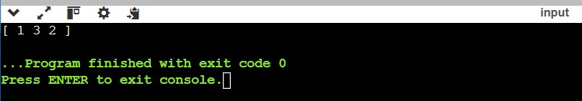

**2. Count Complete Tree Nodes *(Very Easy)***

Given the root of a complete binary tree, return the number of the nodes in the tree.

According to Wikipedia, every level, except possibly the last, is completely filled in a complete binary tree, and all nodes in the last level are as far left as possible. It can have between 1 and 2h nodes inclusive at the last level h.

Design an algorithm that runs in less than O(n) time complexity.

**Example 1:**

**Input:** root = [1,2,3,4,5,6]

**Output:** 6

**Example 2:**

**Input:** root = []

**Output:** 0

**Example 3:**

**Input:** root = [1]

**Output:** 1

**Constraints:**

The number of nodes in the tree is in the range [0, 5 * 104].

0 <= Node.val <= 5 * 104

The tree is guaranteed to be complete.

**Implementation/Code:**

#include <iostream>

using namespace std;

// Definition for a binary tree node.

struct TreeNode {

int val;

TreeNode* left;

TreeNode* right;

TreeNode() : val(0), left(nullptr), right(nullptr) {}

TreeNode(int x) : val(x), left(nullptr), right(nullptr) {}

TreeNode(int x, TreeNode* left, TreeNode* right) : val(x), left(left), right(right) {} };

class Solution { public: int countNodes(TreeNode* root) { if (!root) return 0; int leftDepth = getDepth(root->left); int rightDepth = getDepth(root->right);

if (leftDepth == rightDepth) {

return (1 << leftDepth) + countNodes(root->right);

} else {

return (1 << rightDepth) + countNodes(root->left);

}

}

private:

int getDepth(TreeNode* node) { int depth = 0; while (node) { depth++; node = node->left;

}

return depth;

}

};

// Helper function to create a binary tree

TreeNode* createTree() {

TreeNode* root = new TreeNode(1); root->left = new TreeNode(2); root->right = new TreeNode(3); root->left->left = new TreeNode(4); root->left->right = new TreeNode(5); root->right->left = new TreeNode(6);

return root;

}

int main() {

TreeNode* root = createTree();

Solution sol;

cout << sol.countNodes(root) << endl; return 0;

}

**Output:**

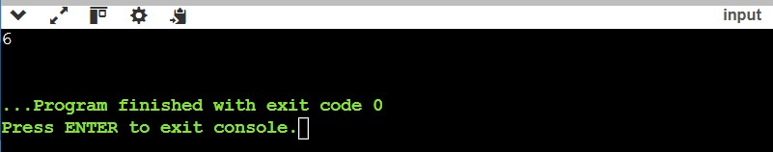

**3. Binary Tree - Find Maximum Depth *(Very Easy)***

A binary tree's maximum depth is the number of nodes along the longest path from the root node down to the farthest leaf node.

**Example 1:**

**Input:** [3,9,20,null,null,15,7]

**Output:** 3

**Example 2:**

**Input:** [1,null,2]

**Output:** 2

**Constraints:**

The number of nodes in the tree is in the range [0, 104].

-100 <= Node.val <= 100

**Implementation/Code:**

#include <iostream> using namespace std;

// Definition for a binary tree node.

struct TreeNode {

int val;

TreeNode* left;

TreeNode* right;

TreeNode() : val(0), left(nullptr), right(nullptr) {}

TreeNode(int x) : val(x), left(nullptr), right(nullptr) {}

TreeNode(int x, TreeNode* left, TreeNode* right) : val(x), left(left), right(right) {} };

class Solution { public: int maxDepth(TreeNode* root) {

if (!root) return 0;

int leftDepth = maxDepth(root->left); int rightDepth = maxDepth(root->right);

return max(leftDepth, rightDepth) + 1;

}

};

// Helper function to create a binary tree

TreeNode* createTree() {

TreeNode* root = new TreeNode(3); root->left = new TreeNode(9); root->right = new TreeNode(20); root->right->left = new TreeNode(15); root->right->right = new TreeNode(7);

return root;

}

int main() {

TreeNode* root = createTree();

Solution sol;

cout << sol.maxDepth(root) << endl; return 0;

}

**Output:**

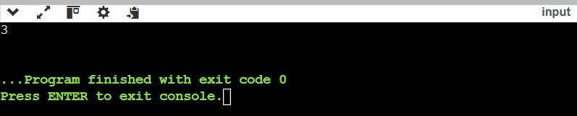

**4.** [**Binary Tree Preorder Traversal**](https://leetcode.com/problems/binary-tree-preorder-traversal/)  ***(Very Easy)***

Given the root of a binary tree, return the preorder traversal of its nodes' values.

**Example 1:**

**Input:** root = [1,null,2,3]

**Output:** [1,2,3]

**Explanation:**



**Example 2:**

**Input:** root = [1,2,3,4,5,null,8,null,null,6,7,9]

**Output:** [1,2,4,5,6,7,3,8,9]

**Explanation:**



**Constraints:**

The number of nodes in the tree is in the range [1, 100].

1 <= Node.val <= 1000

**Implementation/Code:**

#include <iostream> #include <vector>

using namespace std;

// Definition for a binary tree node.

struct TreeNode {

int val;

TreeNode* left;

TreeNode* right;

TreeNode() : val(0), left(nullptr), right(nullptr) {}

TreeNode(int x) : val(x), left(nullptr), right(nullptr) {}

TreeNode(int x, TreeNode* left, TreeNode* right) : val(x), left(left), right(right) {} };

class Solution { public:

vector<int> preorderTraversal(TreeNode* root) {

vector<int> result; preorder(root, result); return result;

}

private: void preorder(TreeNode* node, vector<int>& result)

{ if (!node) return; result.push_back(node->val); preorder(node->left, result);

preorder(node->right, result);

}

};

// Helper function to create a binary tree

TreeNode* createTree()

{

TreeNode* root = new TreeNode(1); root->left = new TreeNode(2); root->right = new TreeNode(3); root->left->left = new TreeNode(4); root->left->right = new TreeNode(5); root->right->right = new TreeNode(8); root->left->right->left = new TreeNode(6); root->left->right->right = new TreeNode(7); root->right->right->left = new TreeNode(9);

return root;

}

int main()

{

TreeNode* root = createTree();

Solution sol;

vector<int> result = sol.preorderTraversal(root);

for (int val : result)

{

cout << val << " ";

} return 0;

}

**Output:**

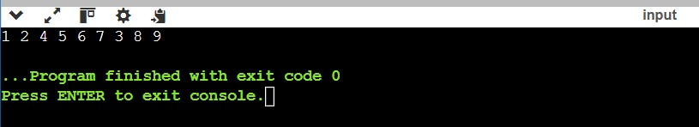

**5. Binary Tree - Sum of All Nodes  *(Very Easy)***

Given the root of a binary tree, you need to find the sum of all the node values in the binary tree.

**Example 1:**

**Input:** root = [1, 2, 3, 4, 5, null, 6]

**Output:** 21

**Explanation:** The sum of all nodes is 1 + 2 + 3 + 4 + 5 + 6 = 21.

**Example 2:**

**Input:** root = [5, 2, 6, 1, 3, 4, 7]

**Output:** 28

**Explanation:** The sum of all nodes is 5 + 2 + 6 + 1 + 3 + 4 + 7 = 28.

**Implementation/Code:**

#include <iostream>

using namespace std;

// Definition for a binary tree node.

struct TreeNode { int val;

TreeNode* left;

TreeNode* right;

TreeNode() : val(0), left(nullptr), right(nullptr) {}

TreeNode(int x) : val(x), left(nullptr), right(nullptr) {}

TreeNode(int x, TreeNode* left, TreeNode* right) : val(x), left(left), right(right) {} };

class Solution

{ public:

int sumOfNodes(TreeNode* root) {

if (!root) return 0;

return root->val + sumOfNodes(root->left) + sumOfNodes(root->right);

}

};

// Helper function to create a binary tree

TreeNode* createTree()

{

TreeNode* root = new TreeNode(1); root->left = new TreeNode(2); root->right = new TreeNode(3); root->left->left = new TreeNode(4); root->left->right = new TreeNode(5); root->right->right = new TreeNode(6);

return root;

}

int main()

{

TreeNode* root = createTree();

Solution sol;

cout << sol.sumOfNodes(root) << endl; return 0;

}

**Output:**

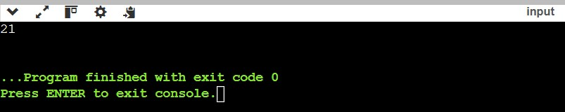

**6. Same Tree *(Easy)***

Two binary trees are considered the same if they are structurally identical, and the nodes have the same value.

**Example 1:**

**Input:** p = [1,2,3], q = [1,2,3]

**Output:** true

**Example 2:**

**Input:** p = [1,2], q = [1,null,2]

**Output:** false

**Constraints:**

The number of nodes in both trees is in the range [0, 100].

-104 <= Node.val <= 104

**Implementation/Code:**

#include <iostream>

using namespace std;

// Definition for a binary tree node.

struct TreeNode { int val;

TreeNode* left;

TreeNode* right;

TreeNode() : val(0), left(nullptr), right(nullptr) {}

TreeNode(int x) : val(x), left(nullptr), right(nullptr) {}

TreeNode(int x, TreeNode* left, TreeNode* right) : val(x), left(left), right(right) {} };

class Solution { public:

bool isSameTree(TreeNode* p, TreeNode* q) { if (!p && !q) return true;

if (!p || !q || p->val != q->val) return false;

return isSameTree(p->left, q->left) && isSameTree(p->right, q->right);

}

};

// Helper function to create a tree

TreeNode* createTree1() { TreeNode* root = new TreeNode(1); root->left = new TreeNode(2); root->right = new TreeNode(3);

return root;

}

TreeNode* createTree2() { TreeNode* root = new TreeNode(1); root->left = new TreeNode(2); root->right = new TreeNode(3);

return root;

}

int main()

{

TreeNode* p = createTree1();

TreeNode* q = createTree2();

Solution sol;

cout << (sol.isSameTree(p, q) ? "true" : "false") << endl; return 0;

}

**Output:**

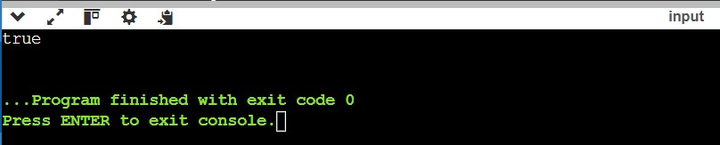

**7. Symmetric Tree  *(Easy)***

**Example 1:**

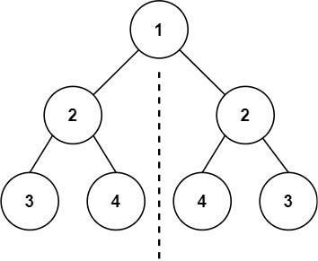

**Input:** root = [1,2,2,3,4,4,3]

**Output:** true

**Example 2:**

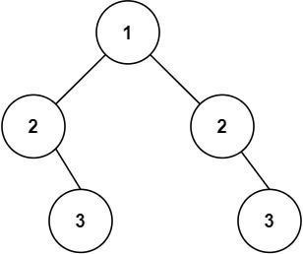

**Input:** root = [1,2,2,null,3,null,3]

**Output:** false

**Constraints:**

The number of nodes in the tree is in the range [1, 1000].

-100 <= Node.val <= 100

**Implementation/Code:**

#include <iostream>

using namespace std;

struct TreeNode {

int val;

TreeNode* left;

TreeNode* right;

TreeNode() : val(0), left(nullptr), right(nullptr) {}

TreeNode(int x) : val(x), left(nullptr), right(nullptr) {}

TreeNode(int x, TreeNode* left, TreeNode* right) : val(x), left(left), right(right) {} };

class Solution { public: bool isSymmetric(TreeNode* root) {

return !root || isMirror(root->left, root->right);

}

private:

bool isMirror(TreeNode* t1, TreeNode* t2) { if (!t1 && !t2) return true;

if (!t1 || !t2 || t1->val != t2->val) return false;

return isMirror(t1->left, t2->right) && isMirror(t1->right, t2->left);

}

};

TreeNode* createTree() {

TreeNode* root = new TreeNode(1); root->left = new TreeNode(2); root->right = new TreeNode(2); root->left->left = new TreeNode(3); root->left->right = new TreeNode(4); root->right->left = new TreeNode(4); root->right->right = new TreeNode(3);

return root;

}

int main() {

TreeNode* root = createTree();

Solution sol;

cout << (sol.isSymmetric(root) ? "true" : "false") << endl; return 0;

}

**Output:**

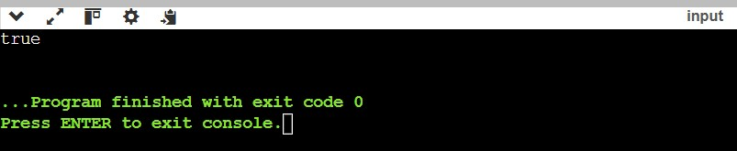

**8. Invert Binary Tree *(Easy)***

Given the root of a binary tree, invert the tree, and return its root.

**Example 1:**

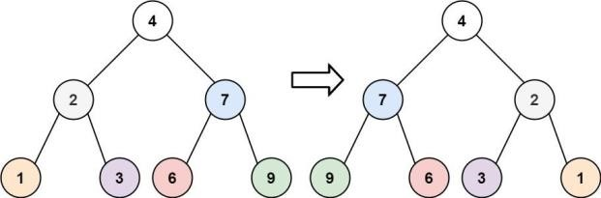

**Input**: root = [4,2,7,1,3,6,9]

**Output:** [4,7,2,9,6,3,1]

**Example 2:**

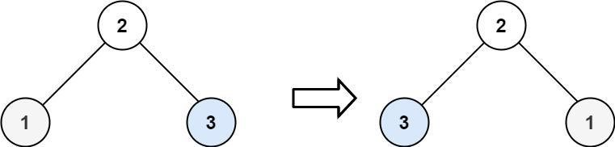

**Input:** root = [2,1,3]

**Output:** [2,3,1]

**Constraints:**

The number of nodes in the tree is in the range [0, 100]. -100 <= Node.val <= 100

**Implementation/Code:**

#include <iostream>

using namespace std;

// Definition for a binary tree node.

struct TreeNode {

int val;

TreeNode* left;

TreeNode* right;

TreeNode() : val(0), left(nullptr), right(nullptr) {}

TreeNode(int x) : val(x), left(nullptr), right(nullptr) {}

TreeNode(int x, TreeNode* left, TreeNode* right) : val(x), left(left), right(right) {} };

class Solution { public:

TreeNode* invertTree(TreeNode* root) {

if (!root) return nullptr; swap(root->left, root->right); invertTree(root->left); invertTree(root->right);

return root;

}

};

// Helper function to create a tree

TreeNode* createTree() {

TreeNode* root = new TreeNode(2); root->left = new TreeNode(1); root->right = new TreeNode(3);

return root;

}

void printTree(TreeNode* root) { if (!root) return; cout << root->val << " "; printTree(root->left); printTree(root->right);

}

int main() {

TreeNode* root = createTree();

Solution sol;

TreeNode* inverted = sol.invertTree(root);

printTree(inverted);

return 0;

}

**Output:**

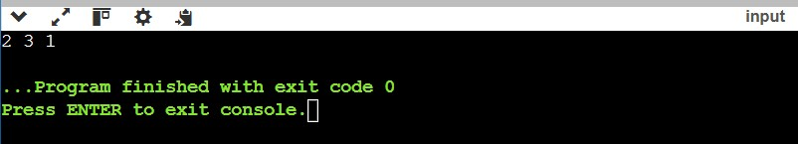

**9. Path Sum *(Easy)***

Given a binary tree and a sum, return **true** if the tree has a root-to-leaf path such that adding up all the values along the path equals the given sum. Return **false** if no such path can be found.

**Example 1:**

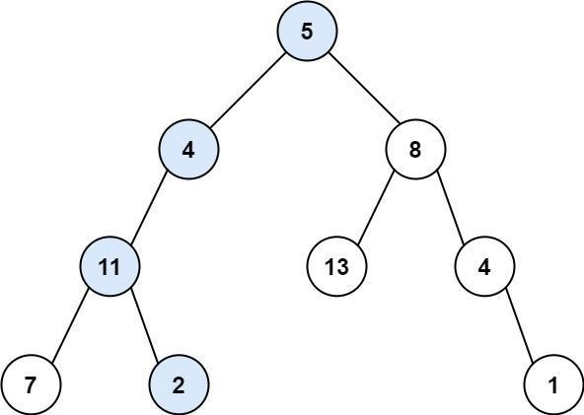

**Input:** root = [5,4,8,11,null,13,4,7,2,null,null,null,1], targetSum = 22

**Output:** true

**Explanation:** The root-to-leaf path with the target sum is shown.

**Example 2:**

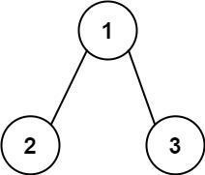

**Input:** root = [1,2,3], targetSum = 5

**Output:** false

**Explanation:** There are two root-to-leaf paths in the tree:

(1 --> 2): The sum is 3.

(1 --> 3): The sum is 4.

There is no root-to-leaf path with sum = 5.

**Example 3:**

**Input:** root = [], targetSum = 0

**Output:** false

**Explanation:** Since the tree is empty, there are no root-to-leaf paths.

**Implementation/Code:**

#include <iostream>

using namespace std;

// Definition for a binary tree node.

struct TreeNode

{

int val;

TreeNode* left;

TreeNode* right;

TreeNode() : val(0), left(nullptr), right(nullptr) {}

TreeNode(int x) : val(x), left(nullptr), right(nullptr) {}

TreeNode(int x, TreeNode* left, TreeNode* right) : val(x), left(left), right(right) {} };

class Solution

{ public: bool hasPathSum(TreeNode* root, int targetSum) {

if (!root) return false;

if (!root->left && !root->right) return root->val == targetSum;

return hasPathSum(root->left, targetSum - root->val) || hasPathSum(root->right, targetSum - root->val);

}

};

// Helper function to create a tree

TreeNode* createTree()

{

TreeNode* root = new TreeNode(5); root->left = new TreeNode(4); root->right = new TreeNode(8); root->left->left = new TreeNode(11); root->right->left = new TreeNode(13); root->right->right = new TreeNode(4); root->left->left->left = new TreeNode(7); root->left->left->right = new TreeNode(2); root->right->right->right = new TreeNode(1); return root;

}

int main()

{

TreeNode* root = createTree();

Solution sol;

cout << (sol.hasPathSum(root, 22) ? "true" : "false") << endl; return 0;

}

**Output:**

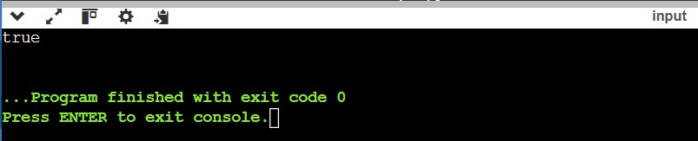

**10. Lowest Common Ancestor of a Binary Tree *(Medium)***

Given a binary tree, find the lowest common ancestor (LCA) of two given nodes in tree.

The lowest common ancestor is defined between two nodes p and q as the lowest node in T that has both p and q as descendants (where we allow a node to be a descendant of itself).

**Example 1:**

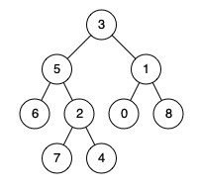

**Input:** root = [3,5,1,6,2,0,8,null,null,7,4], p = 5, q = 1

**Output:** 3

**Explanation:** The LCA of nodes 5 and 1 is 3.

**Example 2:**



**Input:** root = [3,5,1,6,2,0,8,null,null,7,4], p = 5, q = 4

**Output:** 5

**Explanation:** The LCA of nodes 5 and 4 is 5, since a node can be a descendant of itself according to the LCA definition.

**Example 3:**

**Input:** root = [1,2], p = 1, q = 2

**Output:** 1

**Constraints:**

* The number of nodes in the tree is in the range [2, 105]. • -109 <= Node.val <= 109 • All Node.val are unique.
* p != q
* p and q will exist in the tree.

**Implementation/Code:**

#include <iostream>

using namespace std;

// Definition for a binary tree node.

struct TreeNode {

int val;

TreeNode* left;

TreeNode* right;

TreeNode(int x) : val(x), left(nullptr), right(nullptr) {}

};

class Solution { public:

TreeNode* lowestCommonAncestor(TreeNode* root, TreeNode* p, TreeNode* q) { if (!root || root == p || root == q) return root;

TreeNode* left = lowestCommonAncestor(root->left, p, q); TreeNode* right = lowestCommonAncestor(root->right, p, q); return left && right ? root : (left ? left : right); }

};

// Main function int main() {

TreeNode* root = new TreeNode(3); root->left = new TreeNode(5); root->right = new TreeNode(1); root->left->left = new TreeNode(6); root->left->right = new TreeNode(2); root->right->left = new TreeNode(0);

root->right->right = new TreeNode(8);

Solution sol;

TreeNode* lca = sol.lowestCommonAncestor(root, root->left, root->right); cout << lca->val << endl; // Expected: 3 return 0;

}

**Output:**

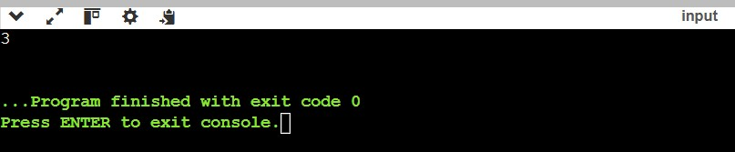

**11. Sum Root to Leaf Numbers *(Medium)***

You are given the root of a binary tree containing digits from 0 to 9 only. Each root-toleaf path in the tree represents a number. A leaf node is a node with no children.

For example, the root-to-leaf path 1 -> 2 -> 3 represents the number 123.

Return the total sum of all root-to-leaf numbers. Test cases are generated so that the answer will fit in a 32-bit integer.

**Example 1:**

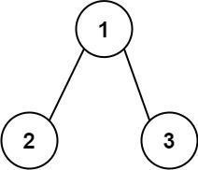

**Input:** root = [1,2,3]

**Output:** 25

**Explanation:**

The root-to-leaf path 1->2 represents the number 12.

The root-to-leaf path 1->3 represents the number 13.

Therefore, sum = 12 + 13 = 25.

**Example 2:**

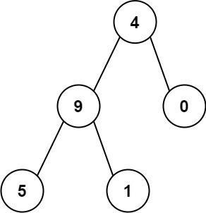

**Input:** root = [4,9,0,5,1] **Output:** 1026 **Explanation:**

The root-to-leaf path 4->9->5 represents the number 495.

The root-to-leaf path 4->9->1 represents the number 491.

The root-to-leaf path 4->0 represents the number 40.

Therefore, sum = 495 + 491 + 40 = 1026.

**Constraints:**

The number of nodes in the tree is in the range [1, 1000].

0 <= Node.val <= 9

The depth of the tree will not exceed 10.

**Implementation/Code:**

#include <iostream>

using namespace std;

// Definition for a binary tree node.

struct TreeNode {

int val;

TreeNode* left;

TreeNode* right;

TreeNode(int x) : val(x), left(nullptr), right(nullptr) {}

};

class Solution { public:

int sumNumbers(TreeNode* root) {

return dfs(root, 0);

}

private: int dfs(TreeNode* node, int currentSum) { if (!node) return 0;

currentSum = currentSum * 10 + node->val; if (!node->left && !node->right) return currentSum;

return dfs(node->left, currentSum) + dfs(node->right, currentSum);

}

};

// Main function int main() {

TreeNode* root = new TreeNode(4); root->left = new TreeNode(9); root->right = new TreeNode(0); root->left->left = new TreeNode(5);

root->left->right = new TreeNode(1);

Solution sol;

cout << sol.sumNumbers(root) << endl; // Expected: 1026 return 0;

}

**Output:**

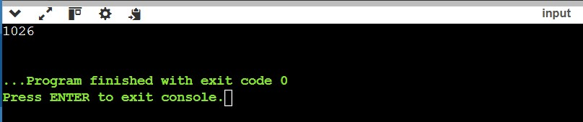

**12. Binary Tree Maximum Path Sum *(Hard)***

A path in a binary tree is a sequence of nodes where each pair of adjacent nodes in the sequence has an edge connecting them.

A node can only appear in the sequence at most once.

Note that the path does not need to pass through the root.

The path sum of a path is the sum of the node's values in the path.

Given the root of a binary tree, return the maximum path sum of any non-empty path.

**Example 1:**

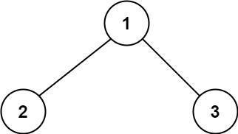

**Input:** root = [1,2,3]

**Output:** 6

**Explanation:** The optimal path is 2 -> 1 -> 3 with a path sum of 2 + 1 + 3 = 6.

**Example 2:**

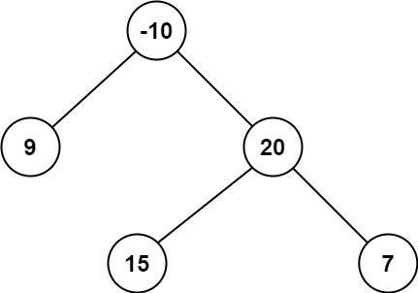

**Input: root =** [-10,9,20,null,null,15,7]

**Output:** 42

**Explanation:** The optimal path is 15 -> 20 -> 7 with a path sum of 15 + 20 + 7 = 42.

**Constraints:**

The number of nodes in the tree is in the range [1, 3 * 104].

-1000 <= Node.val <= 1000

**Implementation/Code:**

#include <iostream>

#include <algorithm> #include <climits> using namespace std;

// Definition for a binary tree node.

struct TreeNode {

int val;

TreeNode* left;

TreeNode* right;

TreeNode(int x) : val(x), left(nullptr), right(nullptr) {}

};

class Solution { public:

int maxPathSum(TreeNode* root) { int maxSum = INT_MIN; maxGain(root, maxSum);

return maxSum;

}

private:

int maxGain(TreeNode* node, int& maxSum)

{

if (!node) return 0;

// Recursively calculate the maximum gain from left and right subtrees int leftGain = max(maxGain(node->left, maxSum), 0);

int rightGain = max(maxGain(node->right, maxSum), 0);

// The current path sum including the current node

int currentPathSum = node->val + leftGain + rightGain;

// Update the maximum path sum if the current path sum is greater

maxSum = max(maxSum, currentPathSum);

// Return the maximum gain the current node contributes to its parent return node->val + max(leftGain, rightGain);

}

};

// Main function int main()

{

TreeNode* root = new TreeNode(-10); root->left = new TreeNode(9); root->right = new TreeNode(20); root->right->left = new TreeNode(15);

root->right->right = new TreeNode(7);

Solution sol;

cout << sol.maxPathSum(root) << endl; // Expected: 42 return 0;

}

**Output:**

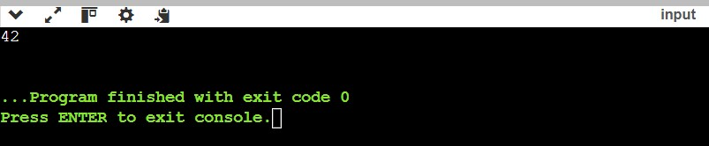

**13. Kth Smallest Element in a BST (Binary Search Tree) *(Hard)***

Given a binary search tree (BST), write a function to find the kth smallest element in the tree.

**Example 1:**

**Input:** root = [3,1,4,null,2], k = 1

**Output:** 1

**Explanation:** The inorder traversal of the BST is [1, 2, 3, 4], and the 1st smallest element is 1.

**Example 2:**

**Input:** root = [5,3,6,2,4,null,null,1], k = 3

**Output:** 3

**Explanation:** The inorder traversal of the BST is [1, 2, 3, 4, 5, 6], and the 3rd smallest element is 3.

**Constraints:**

The number of nodes in the tree is in the range [1, 1000].

-10^4 ≤ Node.val ≤ 10^4.

**Implementation/Code:**

#include <iostream>

#include <stack>

using namespace std;

// Definition for a binary tree node.

struct TreeNode {

int val;

TreeNode* left;

TreeNode* right;

TreeNode(int x) : val(x), left(nullptr), right(nullptr) {}

};

class Solution { public: int kthSmallest(TreeNode* root, int k) { stack<TreeNode*> stk; TreeNode* current = root; int count = 0;

while (current || !stk.empty()) { // Traverse the left subtree while (current) { stk.push(current);

current = current->left;

}

// Visit the node current = stk.top(); stk.pop(); count++;

if (count == k) return current->val;

// Traverse the right subtree

current = current->right;

}

return -1; // This line should never be reached

}

};

// Main function int main() {

TreeNode* root = new TreeNode(5);

root->left = new TreeNode(3); root->right = new TreeNode(6); root->left->left = new TreeNode(2); root->left->right = new TreeNode(4); root->left->left->left = new TreeNode(1);

Solution sol; int k = 3;

cout << sol.kthSmallest(root, k) << endl; // Expected: 3 return 0;

}

**Output:**

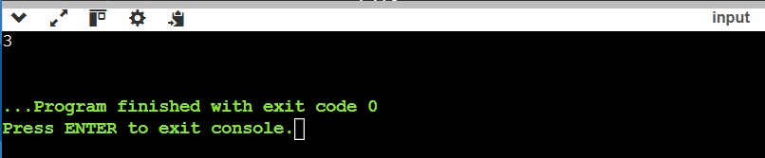

**14. Count Paths That Can Form a Palindrome in a Tree *(Very Hard)***

You are given a tree (i.e. a connected, undirected graph that has no cycles) rooted at node 0 consisting of n nodes numbered from 0 to n - 1. The tree is represented by a 0indexed array parent of size n, where parent[i] is the parent of node i. Since node 0 is the root, parent[0] == -1.

You are also given a string s of length n, where s[i] is the character assigned to the edge between i and parent[i]. s[0] can be ignored.

Return the number of pairs of nodes (u, v) such that u < v and the characters assigned to edges on the path from u to v can be rearranged to form a palindrome.

A string is a palindrome when it reads the same backwards as forwards.

**Example 1:**

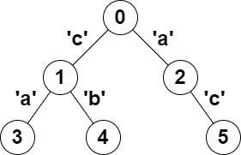

**Input:** parent = [-1,0,0,1,1,2], s = "acaabc"

**Output:** 8

**Explanation:** The valid pairs are:

* All the pairs (0,1), (0,2), (1,3), (1,4) and (2,5) result in one character which is always a palindrome.
* The pair (2,3) result in the string "aca" which is a palindrome.
* The pair (1,5) result in the string "cac" which is a palindrome.
* The pair (3,5) result in the string "acac" which can be rearranged into the palindrome "acca".

**Example 2:**

**Input:** parent = [-1,0,0,0,0], s = "aaaaa"

**Output:** 10

**Explanation:** Any pair of nodes (u,v) where u < v is valid.

**Constraints:** n == parent.length == s.length

1 <= n <= 105

0 <= parent[i] <= n - 1 for all i >= 1 parent[0] == -1 parent represents a valid tree. s consists of only lowercase English letters.

**Implementation/Code:**

#include <iostream>

#include <vector>

#include <unordered_map> #include <bitset>

using namespace std;

class Solution { public: int countPalindromePaths(vector<int>& parent, string s) { int n = parent.size(); vector<vector<int>> tree(n); for (int i = 1; i < n; ++i) {

tree[parent[i]].push_back(i);

}

unordered_map<int, int> freq; freq[0] = 1; // Base case: empty path

int result = 0;

dfs(0, 0, tree, s, freq, result); return result;

}

private:

void dfs(int node, int mask, vector<vector<int>>& tree, string& s, unordered_map<int, int>& freq, int& result) {

// Update the mask by flipping the bit corresponding to the current character mask ^= (1 << (s[node] - 'a'));

// Check for palindromic paths result += freq[mask]; // Exact match

for (int i = 0; i < 26; ++i) {

result += freq[mask ^ (1 << i)]; // One bit difference

}

// Update the frequency map freq[mask]++;

// Recur for children for (int child : tree[node]) { dfs(child, mask, tree, s, freq, result);

}

// Backtrack freq[mask]--;

}

};

// Main function int main() { Solution sol;

vector<int> parent1 = {-1, 0, 0, 1, 1, 2}; string s1 = "acaabc";

cout << sol.countPalindromePaths(parent1, s1) << endl; // Expected: 8

vector<int> parent2 = {-1, 0, 0, 0, 0}; string s2 = "aaaaa";

cout << sol.countPalindromePaths(parent2, s2) << endl; // Expected: 10

return 0;

}

**Output:**

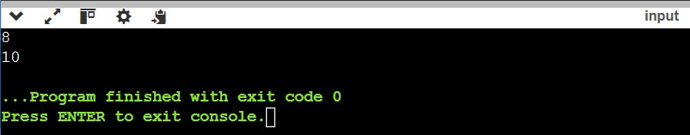

**15. Maximum Number of K-Divisible Components  *(Very Hard)***

There is an undirected tree with n nodes labeled from 0 to n - 1. You are given the integer n and a 2D integer array edges of length n - 1, where edges[i] = [ai, bi] indicates that there is an edge between nodes ai and bi in the tree.

You are also given a 0-indexed integer array values of length n, where values[i] is the value associated with the ith node, and an integer k. Return the maximum number of components in any valid split.

A valid split of the tree is obtained by removing any set of edges, possibly empty, from the tree such that the resulting components all have values that are divisible by k, where the value of a connected component is the sum of the values of its nodes.

**Example 1:**

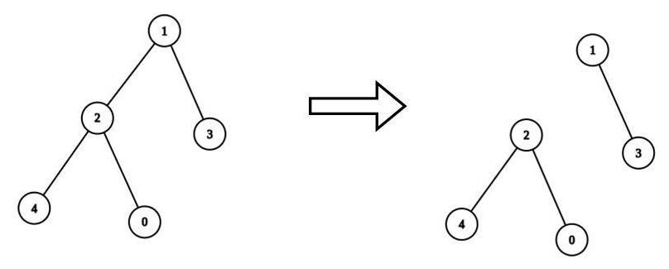

**Input:** n = 5, edges = [[0,2],[1,2],[1,3],[2,4]], values = [1,8,1,4,4], k = 6

**Output:** 2

**Explanation:**

We remove the edge connecting node 1 with 2. The resulting split is valid because:

* The value of the component containing nodes 1 and 3 is values[1] + values[3] = 12. - The value of the component containing nodes 0, 2, and 4 is values[0] + values[2] + values[4] = 6.

It can be shown that no other valid split has more than 2 connected components.

**Example 2:**

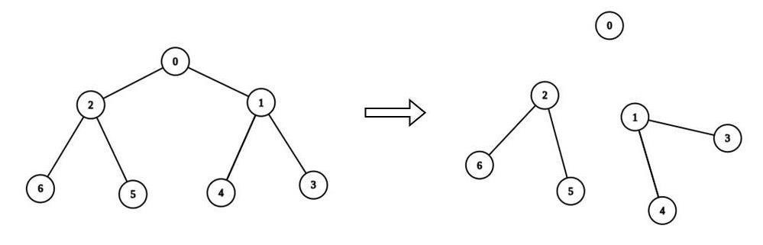

**Input:** n = 7, edges = [[0,1],[0,2],[1,3],[1,4],[2,5],[2,6]], values = [3,0,6,1,5,2,1], k = 3

**Output:** 3

**Explanation:**

We remove the edge connecting node 0 with 2, and the edge connecting node 0 with 1.

The resulting split is valid because:

* The value of the component containing node 0 is values[0] = 3.
* The value of the component containing nodes 2, 5, and 6 is values[2] + values[5] + values[6] = 9.
* The value of the component containing nodes 1, 3, and 4 is values[1] + values[3] + values[4] = 6.

It can be shown that no other valid split has more than 3 connected components.

**Constraints:**

1 <= n <= 3 * 104 edges.length == n - 1 edges[i].length == 2 0 <= ai, bi < n values.length == n 0 <= values[i] <= 109

1 <= k <= 109

Sum of values is divisible by k.

The input is generated such that edges represents a valid tree.

**Implementation/Code:**

#include <iostream> //Programming in C++

#include <vector> using namespace std;

class Solution { public:

int maxKDivisibleComponents(int n, vector<vector<int>>& edges, vector<int>& values, int k) {

vector<vector<int>> tree(n); for (auto& edge : edges) { tree[edge[0]].push_back(edge[1]); tree[edge[1]].push_back(edge[0]); }

int components = 0;

dfs(0, -1, tree, values, k, components); return components;

}

private:

int dfs(int node, int parent, vector<vector<int>>& tree, vector<int>& values, int k, int& components) { int sum = values[node]; for (int child : tree[node]) { if (child != parent) {

sum += dfs(child, node, tree, values, k, components);

}

}

if (sum % k == 0) { components++;

return 0; // Reset sum for this component

}

return sum;

}

};

int main() { Solution sol;

int n1 = 5;

vector<vector<int>> edges1 = {{0, 2}, {1, 2}, {1, 3}, {2, 4}}; vector<int> values1 = {1, 8, 1, 4, 4};

int k1 = 6; cout << sol.maxKDivisibleComponents(n1, edges1, values1, k1) << endl; // Expected: 2

int n2 = 7;

vector<vector<int>> edges2 = {{0, 1}, {0, 2}, {1, 3}, {1, 4}, {2, 5}, {2, 6}}; vector<int> values2 = {3, 0, 6, 1, 5, 2, 1}; int k2 = 3; cout << sol.maxKDivisibleComponents(n2, edges2, values2, k2) << endl; // Expected: 3

return 0;

}

**Output:**

